 | REPUBLIC OF BULGARIA  STATE COMMISSION ON INFORMATION SECURITY

REFERENCE FOR THE INTERNATIONAL LEGAL FRAMEWORK OF THE REPUBLIC OF BULGARIA IN THE FIELD OF PROTECTION OF CLASSIFIED INFORMATION
(Last updated 19.10.2005)

STATE | STATUS OF NEGOTIATIONS
1. POLAND  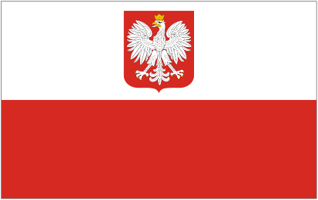 | Signed - 7 April 2005  Approved by DCM of 2 June 2005
2. SPAIN  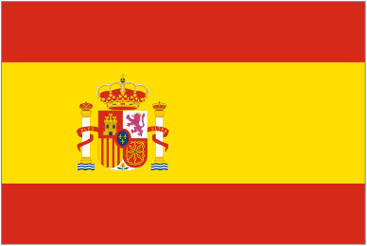 | Signed - 27 September 2005, Madrid  Forthcoming ratification and entering into force
3. ROMANIA  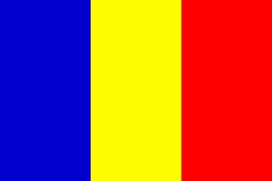 | Draft approved by DCM of 6 January 2005  Forthcoming signing
4. GREECE   | Signed - 17 June 2005  Forthcoming ratification and entering into force
5. FRANCE   | Direct negotiations held  Forthcoming signing
6.CROATIA  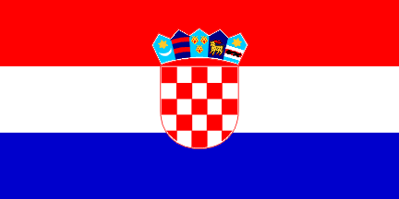 | Process of talks
7. CZECH REPUBLIC  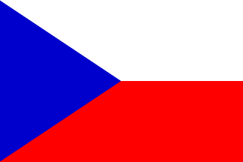 | Forthcoming direct negotiations
8. PORTUGAL  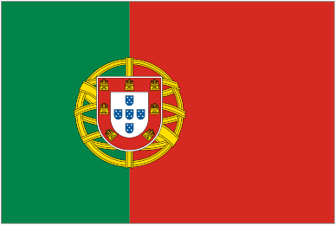 | Forthcoming direct negotiations  Forthcoming signing
9. SWITZERLAND   | Process of talks
10. MACEDONIA  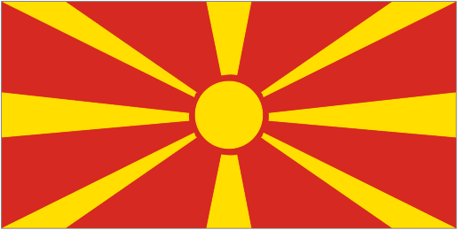 | Signed - 7 October 2005  Forthcoming ratification and entering into force
11. SLOVAKIA  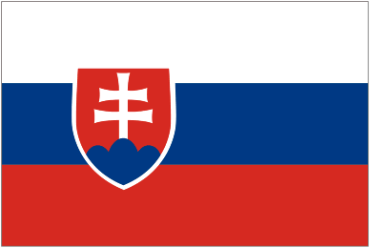 | Direct negotiations held  Forthcoming signing
12. NORWAY  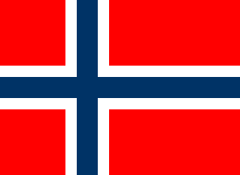 | Direct negotiations held  Forthcoming signing
13. ITALY   | Signed – 8 July 2005  Forthcoming ratification and entering into force
14. HUNGARY  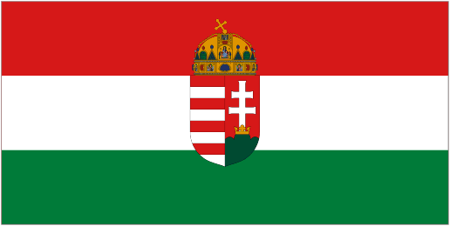 | Process of talks  Forthcoming II-nd round of negotiations in Sofia
15. SERBIA AND MONTENEGRO  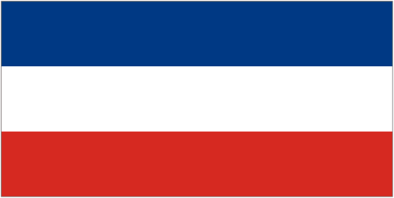 | Process of talks
16. TURKEY  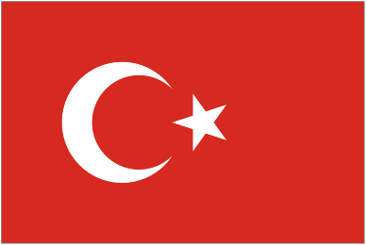 | Process of talks
17. FINLAND  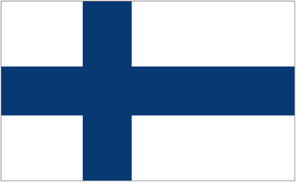 | Process of talks
18. RUSSIAN FEDERATION  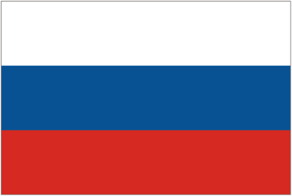 | Process of talks
19. LITHUANIA   | Direct negotiations held  Forthcoming signing
20. MOLDOVA  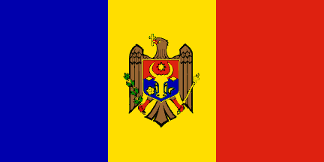 | Forthcoming direct negotiations
21. МALTA  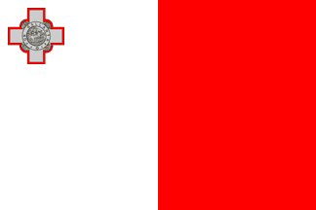 | Process of talks

